- The Monetary Policy Committee voted to hold Bank Rate at 5% at its meeting this week. Most MPC members concluded that, in the absence of material economic news, leaving Bank Rate unchanged was in keeping with its previous messaging that the MPC would take a gradual approach to cutting rates. We still expect the next cut will be 25bps in November.
- The MPC also voted to maintain the pace of quantitative tightening at £100bn over the next year. Of this amount, the bulk will come from redemptions, with a sharp drop in gilt sales. But in contrast to markets, we see little reason for the pace of QT to slow from 2025.
The Bank of England's Monetary Policy Committee had used the minutes of the August meeting to send a clear message that sequential rate cuts were unlikely unless the subsequent economic data was much weaker than anticipated. Going into this week there had been an absence of material economic developments since then, leaving August's inflation data as the last potential trigger of a change of tack.
In the event, the inflation data offered few surprises. CPI inflation was unchanged at 2.2% in August, reflecting two offsetting forces. The fuel category weighed on the headline rate to a greater extent, following a 1.5% m/m fall in petrol prices between July and August this year, compared to a 3.7% rise in the same period last year. But this was counterbalanced with higher services inflation, owing to base effects after an unusually low outturn in August 2023, and a spike in the notoriously volatile air fares component.
In the near-term, the headline inflation rate is likely to be volatile. Though an unusually high services inflation reading in September 2023 should temporarily pull headline inflation below the BoE's 2% target in next month's release, a 10% rise in the Ofgem energy price cap is set to drive inflation higher again from October. Indeed, we expect the shrinking drag from the energy category will push headline inflation up to 2.5% around the turn of the year, which is in line with the MPC's current expectations (Chart 1).
Chart 1: Our latest forecast sees inflation rising towards the end of this year
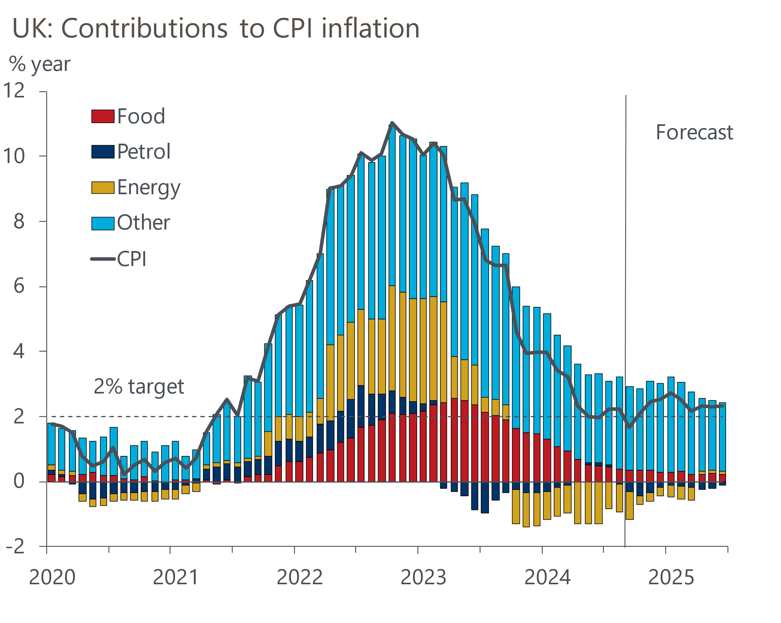
Source: Oxford Economics, Haver Analytics

With no reason to deviate from their previous guidance, the MPC voted 8-1 to leave Bank Rate unchanged at 5%. Long-time dove Swati Dhingra was the sole dissenter, voting for another 25bps cut on the grounds that Bank Rate needed to become less restrictive now to enable a smooth transition in the policy stance and to account for lags in the monetary transmission mechanism. However, the minutes highlighted that most members who preferred to keep Bank Rate at 5% concluded that "in the absence of material developments, a gradual approach to removing policy restraint would be warranted".
We see another rate cut in November as almost certain. This would be consistent with the MPC's message that it will move gradually. That the minutes pointed to the importance of the November forecast round, just as June's minutes did ahead of the decision to cut in August, lends further weight to the view that the committee sees the next meeting as the appropriate juncture to loosen policy again.
Furthermore, we think the balance of risks is skewed towards the MPC cutting rates more aggressively around the turn of the year, either by following the Federal Reserve's lead and cutting by 50bps, or by cutting at successive meetings. A more aggressive tightening of fiscal policy in the Budget on October 30 appears to be the most plausible trigger for such a scenario.
Beyond its rate decision, the MPC also voted unanimously to reduce the stock of gilts held in the BoE's Asset Purchase Facility by £100bn over the next year – the same pace of quantitative tightening as over the past year. Of this amount, £87bn will come from gilt redemptions, leaving just £13bn of active sales, down from £50bn last year (Chart 2).
Chart 2: Holding the pace of QT constant implies a choppy profile for gilt sales going forward
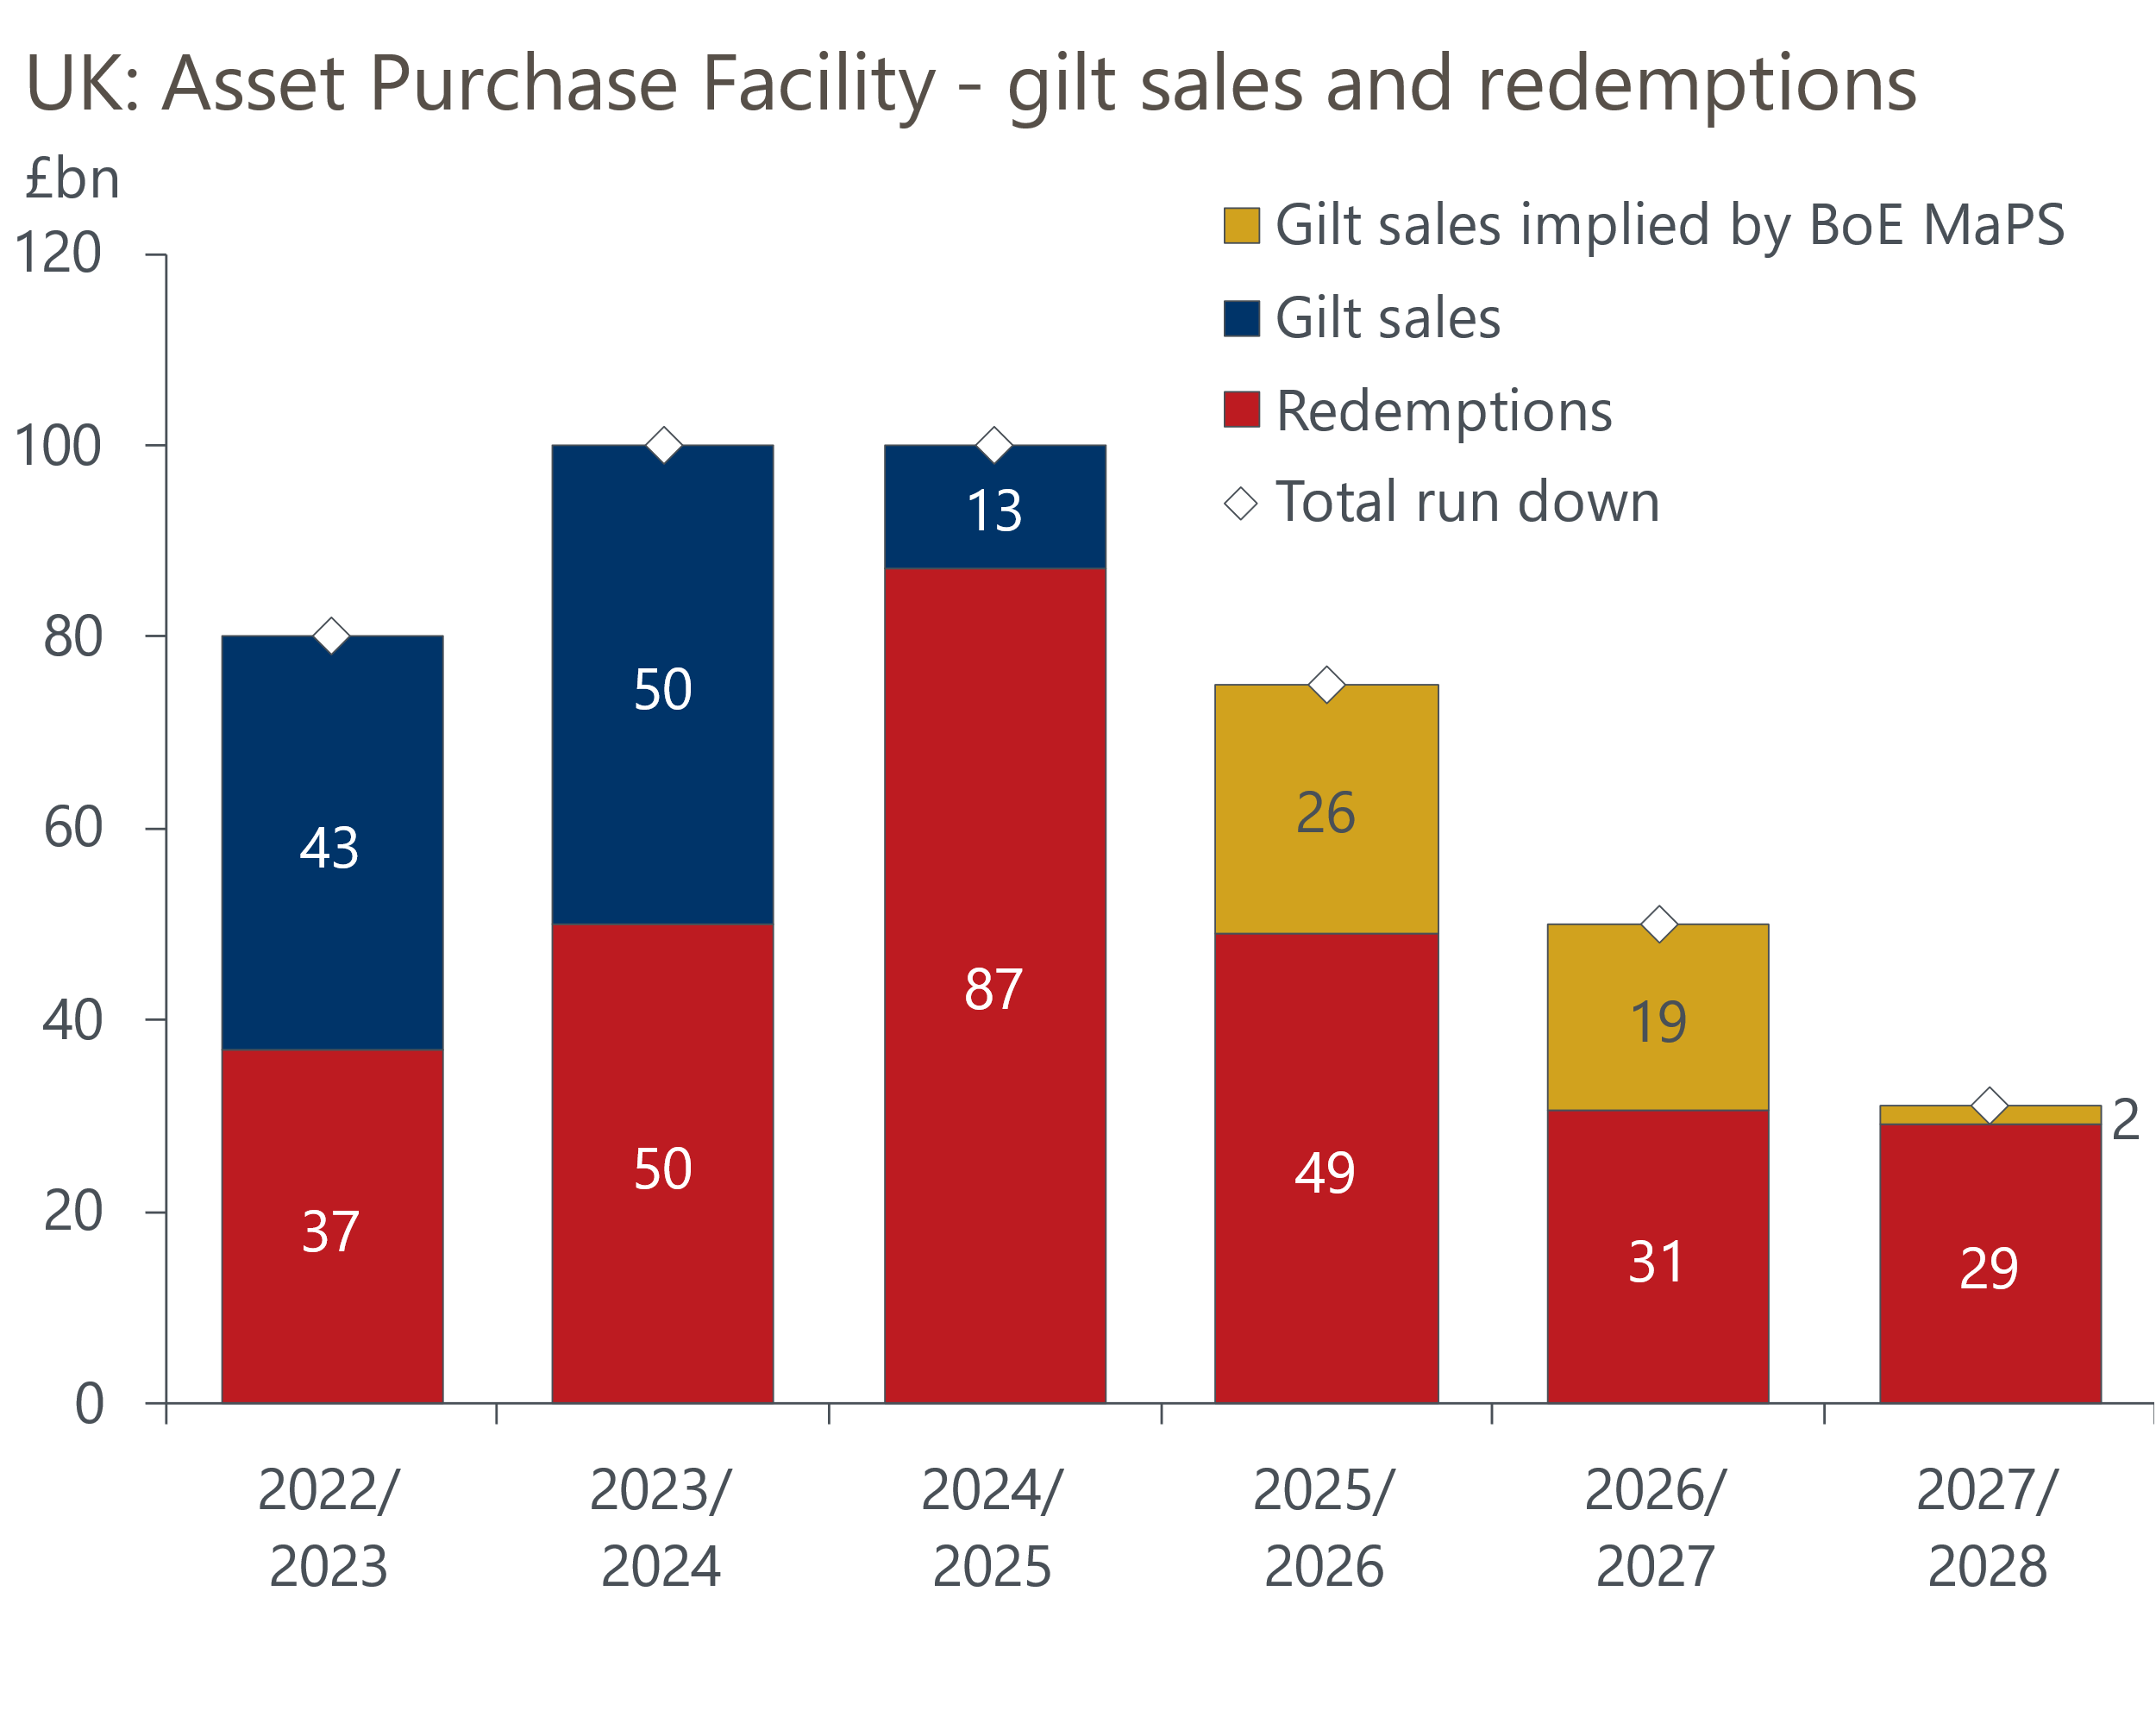
Sources: Oxford Economics calculations using data from Haver Analytics & Bank of England
No guidance was provided on how the MPC expects to run down what will remain of its balance sheet beyond September 2025. Last month's BoE Market Participants Survey suggested that respondents expect the pace of QT to moderate from 2025-2026, although considering the value of redemptions will drop sharply, this still implies the level of gilt sales will temporarily rise again.
The expectation that the pace of QT will slow partly reflects where market participants deem the equilibrium level of bank reserves to be. Their fear is that if reserves fall below that level, it could add upward pressure and volatility to short-term rates.
However, we think this concern is misplaced because the BoE can use a major expansion of short-term repos as the counterpart to a persistently high level of bank reserves. Given the box in August's Monetary Policy Report made clear that the BoE thinks QT is having a negligible impact on gilt yields and can run in parallel with its rate-cutting cycle, we think the BoE will continue to run down the APF at the current pace in subsequent years until all the gilts have been sold.

The week ahead
Next week's only release of note is the flash S&P Global survey for September. August saw the PMIs rise in both sectors, though the survey's forward-looking indicators point to some sectoral divergence ahead. Last month's manufacturing survey reported strong increases in new orders and hiring, while business expectations for future production remained upbeat. Therefore, we expect production levels to edge up and the flash manufacturing PMI to rise to 52.7 in September. In contrast, firms in the services sector reported a softening in new orders and business sentiment, so we think September's flash services PMI will cool to 53.0. This would leave the flash composite PMI around 53.1.
Table 1: Week ahead calendar
Date | Events | Period | Measure | Unit | Previous | Forecast
Sep 18 | S&P Global manufacturing | Sep | PMI | % bal | 52.5 | 52.7
Sep 18 | S&P Global services | Sep | PMI | % bal | 53.7 | 53.0
Sep 18 | S&P Global composite | Sep | PMI | % bal | 53.8 | 53.1
Source: Oxford Economics

Key forecasts
Table 2: UK forecast overview
(Annual percentage changes unless specified)
 | 2022 | 2023 | 2024 | 2025 | 2026 | 2027
GDP | 4.3 | 0.1 | 1.1 | 1.7 | 1.8 | 1.7
Private consumption | 4.8 | 0.2 | 0.6 | 2.1 | 2.0 | 1.6
Fixed investment | 8.0 | 2.2 | 0.3 | 0.9 | 2.5 | 2.1
Government consumption | 2.3 | 0.5 | 2.7 | 2.8 | 1.6 | 1.5
Exports of goods and services | 9.0 | -0.5 | -1.1 | 2.1 | 2.0 | 1.7
Imports of goods and services | 14.6 | -1.5 | 0.8 | 2.5 | 2.6 | 1.9
Industrial Production | -3.5 | -0.4 | -0.1 | 0.8 | 1.5 | 1.1
Consumer prices | 9.1 | 7.3 | 2.6 | 2.6 | 2.2 | 2.1
Unemployment rate (%) | 3.9 | 4.0 | 4.3 | 4.3 | 4.1 | 3.9
Current a/c balance (% of GDP) | -3.1 | -3.3 | -3.6 | -3.2 | -3.2 | -3.2
Government balance (% of GDP) | 4.4 | 5.0 | 4.0 | 3.2 | 2.5 | 1.7
Cen. bank policy rate (%, EOP) | 3.50 | 5.25 | 4.75 | 3.75 | 2.75 | 2.00
10yr govt. bond yield (%, EOP) | 3.67 | 3.54 | 3.93 | 3.67 | 3.24 | 2.85
Exchange rate (US$ per £, EOP) | 1.20 | 1.27 | 1.29 | 1.30 | 1.31 | 1.33
Exchange rate (euro per £, EOP) | 1.13 | 1.15 | 1.19 | 1.19 | 1.18 | 1.17
Source: Oxford Economics
Table 3: Quarterly forecasts for the UK
 | 2024 |  |  |  | 2025
 | Q1 | Q2 | Q3 | Q4 | Q1 | Q2 | Q3 | Q4
GDP (% year) | 0.3 | 0.9 | 1.3 | 2.1 | 1.8 | 1.6 | 1.7 | 1.7
CPI inflation (% year) | 3.5 | 2.1 | 2.1 | 2.5 | 2.7 | 2.5 | 2.7 | 2.5
Bank Rate (%, EOP) | 5.25 | 5.25 | 5.00 | 4.75 | 4.50 | 4.25 | 4.00 | 3.75
10yr gilt yield (%, EOP) | 3.95 | 4.17 | 3.95 | 3.93 | 3.87 | 3.80 | 3.74 | 3.67
US$ per £ (EOP) | 1.26 | 1.26 | 1.30 | 1.29 | 1.29 | 1.29 | 1.30 | 1.30
Euro per £ (EOP) | 1.17 | 1.18 | 1.19 | 1.19 | 1.19 | 1.19 | 1.19 | 1.19
Source: Oxford Economics

Latest Country Economic Forecast:
September 13, 2024

Recent publications

Data Insights
August's retail data consolidated July's rebound in sales
Public finances leave no wiggle room ahead of Autumn Budget
August's inflation data unlikely to trigger a September rate cut
GDP flatlined for the second consecutive month in July
Labour market data consistent with gradual pace of rate cuts

Research Briefings
MPC takes a breath, but cuts likely to resume in November
MPC preview – Pace of gilts sell-off is the key decision
MPC easing - how far and how fast?
Growth may slow, but the consensus looks too weak
Rate-cut cycle kicks off but it’s unlikely to be sequential

Contacts

Oxford Economics' UK team
- Andrew Goodwin - Chief UK Economist - agoodwin@oxfordeconomics.com
- Edward Allenby - UK Economist - eallenby@oxfordeconomics.com

